Actualización BIOS (v1.23).
- Ejecutamos fichero r2guj13w. Aceptamos las condiciones.
- Seleccionamos solo extraer ficheros:
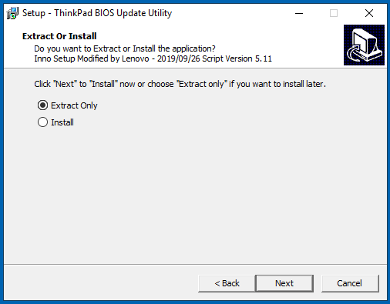
- Colocamos el fichero logo.jpg en el siguiente directorio. Si no lo ha generado el instalador, se ha de hacer a mano:
C:\DRIVERS\FLASH\r2guj13w\...\Rfs\StartupImages
- Ejecutamos el fichero WINUPTP.exe. El sistema realizará la actualización de la BIOS.
(ruta C:\DRIVERS\FLASH\ r2guj13w\...).
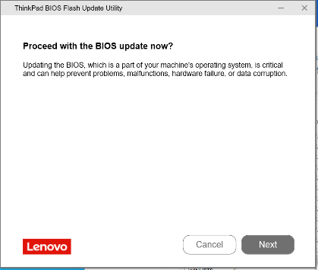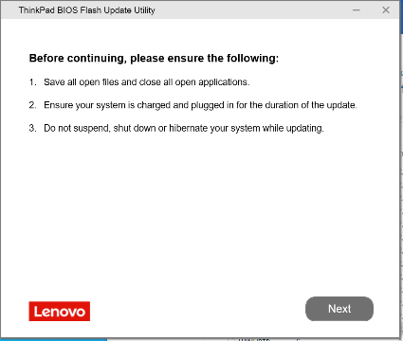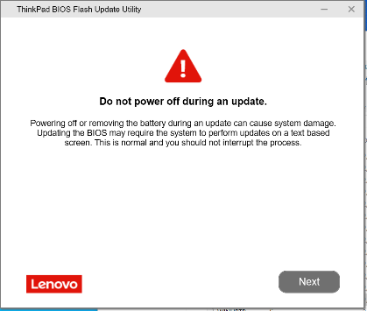
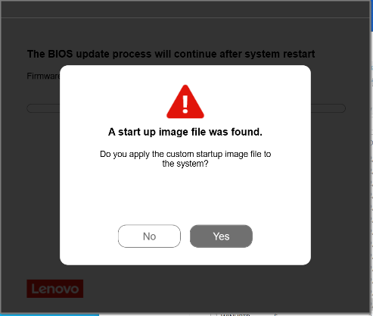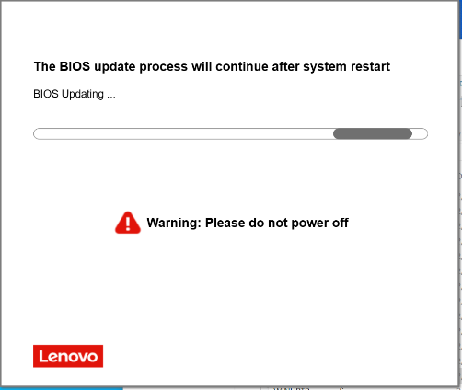
Package | BIOS | (BIOS ID) | ECP | (ECP ID) | Rev. | Issue Date
r2guj13w | 1.23 | (R2GET41W) | 1.09 | (R2GHT28W) | 01 | 2026/04/14

Una vez finalizado, el sistema se reinicia. Dejamos que finalicen los trabajos de actualización.
Una vez dentro de Windows, eliminamos la carpeta generada (C:\Drivers\....\ ).

Carga de valores.
- Ejecutamos fichero ThinkBiosConfig.
- Seleccionamos el fichero *.ini del producto que queremos configurar y pulsamos en ejecutar.
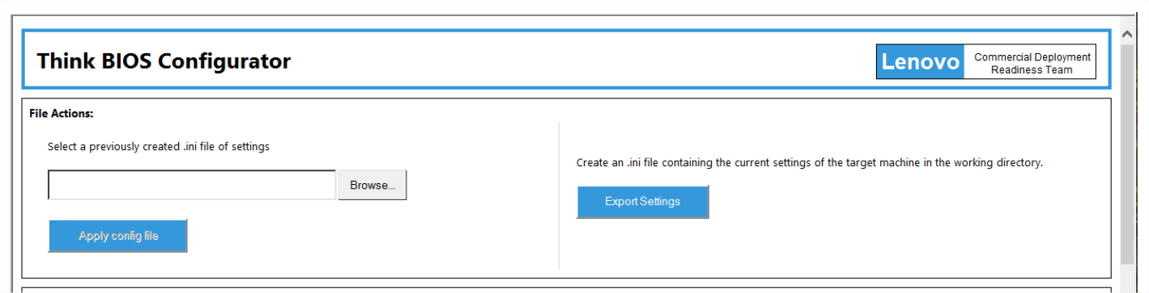
- El sistema nos dirá que tras el reinicio se aplicarán los cambios.

Summary of Changes:
<R2GUJ13W>
UEFI: 1.23/ ECP: 1.09
- (New) Enabled BIOS backup.

<R2GUJ12W>
UEFI: 1.22/ ECP: 1.09
- [Important] Enhancement to address security vulnerability, LEN-2058212, LEN-2072013, LEN-207202.
- (New) Updated Version 04.44.000 code of FIT's InROM diagnostics.
- (New) Updated UEFI CA for Lenovo Cloud Server.

<R2GUJ11W>
UEFI: 1.21/ ECP: 1.08
- [Important] Enhancement to address security vulnerability, CVE-2025-2295, CVE-2025-3052, CVE-2025-20064
- (New) Support SK Hynix memory.
- (New) Support Camera WU.
- (New) Updated PD FW Version to R2GPD07W.
- (Fix) Fixed an issue that the USB3.2 Gen2 Portable SSD Recognition Fails after Restart.
- (Fix) Fixed an issue that the 65W Type-C adapter is not able to charge.

<R2GUJ10W>
UEFI: 1.18/ ECP: 1.06
- (New) Support BIOS Single capsule.
- (New) Support new Samsung and Micron memory.
- (Fix) Fixed an issue where the POST screen message would disappear immediately.

<R2GUJ09W>
UEFI: 1.16/ ECP: 1.06
- [Important] Enhancement to address security vulnerabilities.
- (New) Update GOP setting.
- (Fix) Combined with camera FW R2GCC01W/R2GCD01W to fix rear camera display up side down in google meet web.

<R2GUJ08W>
UEFI: 1.15/ ECP: 1.06
- (Fix) Fixed an issue that unit always shows MESSAGE "configuration changed" when BIOS setting Fingerprint Reader: OFF.
- (Fix) Fixed an issue thatDOA TouchPad sometimes not working.
- (Fix) Fixed screen flickering issue.
<R2GUJ07W_v2>
UEFI: 1.14/ ECP: 1.05
-[Important] Fixed an issue where BIOS Update Utility will be blocked by Microsoft "Vulnerable Driver Blocklist ".

<R2GUJ07W>
UEFI: 1.14/ ECP: 1.05
-[New] Update MRC to 1.4.12.0
- [New]Improve Power LED in DC mode.
- (Fix) Fixed touch device doesn't work in pre-boot authentication application.

<R2GUJ06W>
UEFI: 1.12 / ECP: 1.04
-[Important] Fixed an issue that trackpoint can't work in one key recovery mode.

<R2GUJ05W>
UEFI: 1.11 / ECP: 1.04
-[Important] Support WIFI6E.
-(New) Support one key recovery function.

<R2GUJ04W>
UEFI: 1.10 / ECP: 1.04
-[Important] Update kernel code to avoid BIOS and ME back up issue.

<R2GUJ03W>
UEFI: 1.08 / ECP: 1.02
-[Important]Please update MEFW 18.0.5.2141(r2grg01w) firstly then update r2guj03w BIOS.
-[Important]Added Energy Efficient Turbo option in BIOS .
-[Important]Updated Microsoft CA certificate.
-[Important]Disable BIOS backup temporary to prevent boot fail.
-(New)Improved post time.
-(New)Enabled WiFi-6E for Taiwan.

<R2GUJ02W>
UEFI: 1.07 / ECP: 1.01
-[Important]Withdraw in order to prevent reset loop symptom when BIOS update to version 1.07(R2GET25W), and please revert them to previous R2GUJ01W/R2GUR01W (R2GET24W) BIOS.
-[Important] Added Energy Efficient Turbo option in BIOS.
-[Important] Updated Microsoft CA certificate.
-(New) Improve post time.
-(New) Enabled WiFi-6E for Taiwan.

<R2GUJ01W>
UEFI: 1.06 / ECP: 1.00
- (New) Initial Released
Support ThinkPad L13 Gen5 (Machine Types 21LB, 21LC)
ThinkPad L13 2-in-1 Gen5 (Machine Types 21LM,21LN)
ThinkPad S2 Gen 9 (Machine Types 21LQ)

